OF261023, 26.10.2026

INDUSTRIAL GAS TURBINE CHP / TRIGENERATION PLANT
Complete Used Plant Available for Sale
Natural Gas | 50 Hz | Approx. 7.6 MW Site Output | Multi-Utility Heat Recovery
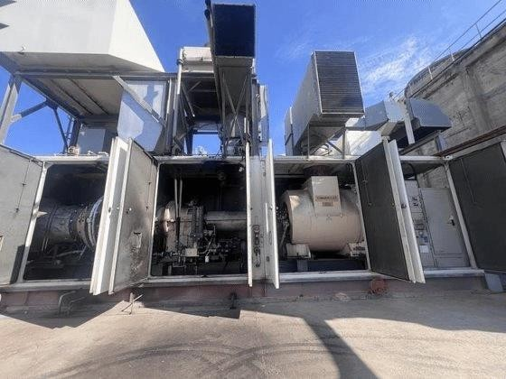
Gas turbine package - current installed asset

TURBINE | ISO OUTPUT | GENERATOR | STATUS
Siemens SGT-300 | 7.9 MW | 6.3 kV / 50 Hz | Shut down Nov. 2025

1,990 000 EUR

Complete details of the scope of supply will be sent if you are interested.

We inspected the plant in September

Asset Offered for Sale

The Owner is offering for sale its complete industrial gas-turbine Combined Heat and Power (CHP) / regeneration plant, installed for continuous industrial service and now available following cessation of production at the host facility in November 2025.
The asset is centred on a Siemens SGT-300 (TEMPEST) single-shaft natural-gas turbine with Dry Low Emission (DLE) combustion, coupled through a reduction gearbox to a 50 Hz AC generator. The generating package is integrated with a substantial waste-heat recovery system designed to convert turbine exhaust energy into useful process utilities.
The sale is intended as an opportunity to acquire the complete installed energy asset - turbine-generator, heat-recovery equipment, electrical and control systems and associated auxiliaries - for dismantling and relocation by the purchaser, subject to the final agreed scope of supply.
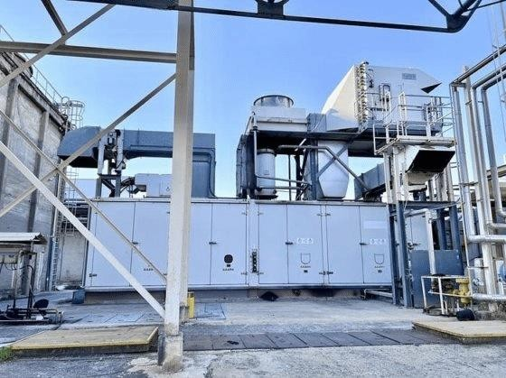
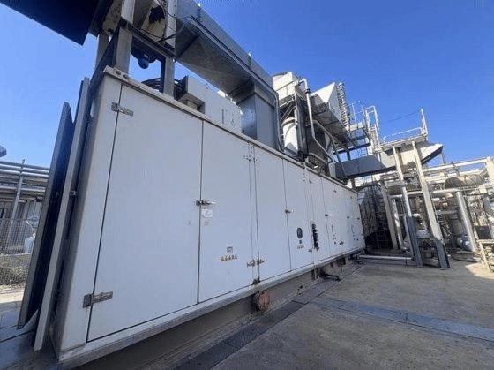
Installed turbine-generator package and enclosure Side view of the installed package and associated
ducting

Present status
- Plant shut down in November 2025 when production at the site ceased.
- Total recorded running hours: 116,131 hours.
- Total recorded starts: 677.
- HP rotor replaced in June 2025. Owner information indicates approximately 8,000 hours of remaining operating time associated with the replacement rotor.

Gas Turbine and Generator

PARAMETER | AVAILABLE / REPORTED DATA
Manufacturer | Siemens
Engine type | SGT-300 (TEMPEST)
Engine nameplate year of construction | 2007
Plant installation / stated plant year | 2008
Type | Industrial single-shaft gas turbine
Fuel | Natural gas
Combustion | Dry Low Emission (DLE)
ISO electrical output | 7.9 MW
Reported site output | Approx. 7.6 MW
Generator voltage | 6.3 kV
Frequency | 50 Hz
Generator speed | 1,500 rpm
Electrical efficiency | Approx. 30.5%
Exhaust gas flow | 30.2 kg/s
Exhaust gas temperature | 545 °C
Duty | Continuous industrial operation
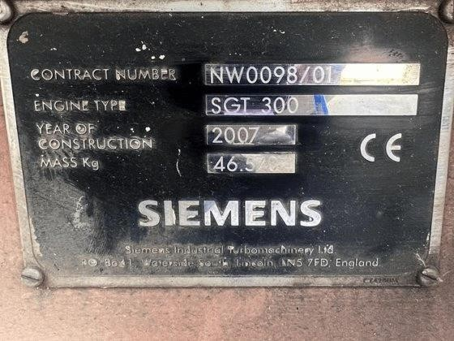
Original Siemens engine nameplate. The plate identifies engine type SGT 300 and year of construction 2007.
Seller clarification: the available plant information describes the installation as a 2008 plant, while the photographed Siemens engine nameplate itself states 2007 as the engine year of construction. Both are shown transparently in this presentation.

Heat Recovery / Trigeneration Plant

The plant was configured as a true industrial cogeneration / regeneration installation. In addition to electricity generation, the exhaust heat-recovery train was designed to produce several process-energy streams from the same fuel input.

SYSTEM / UTILITY | AVAILABLE CONFIGURATION
Thermal oil heater | DOWNTHERM A - 4.3 MW
Thermal oil heater | SANTOTHERM 66 - 3.88 MW
High-pressure steam generator | 25-26 bar
Low-pressure steam generator | 4.5 bar
Hot-water generator | Included
Chiller and 2 gasboilers

Useful energy produced by the installed plant
  - Electrical power
  - High-pressure steam
  - Low-pressure steam
  - Thermal oil
  - Hot water
  - Chilled water
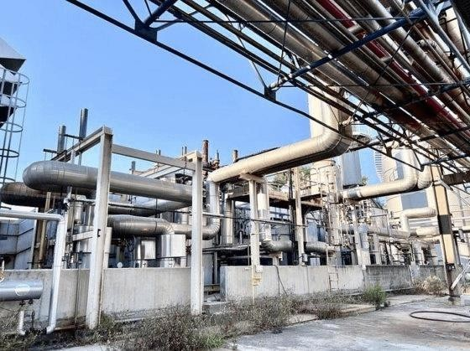
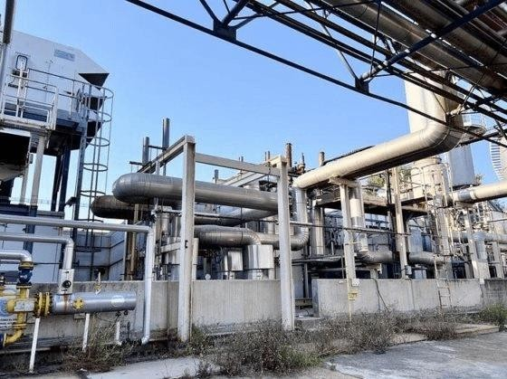

Heat-recovery/process equipment and interconnecting pipework
Additional view of the installed heat-recovery/process area

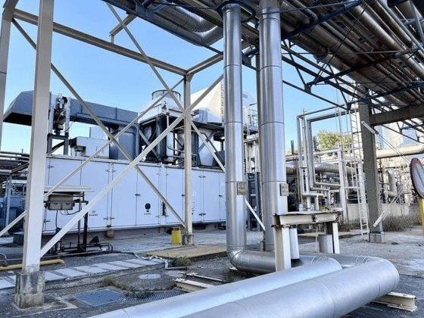
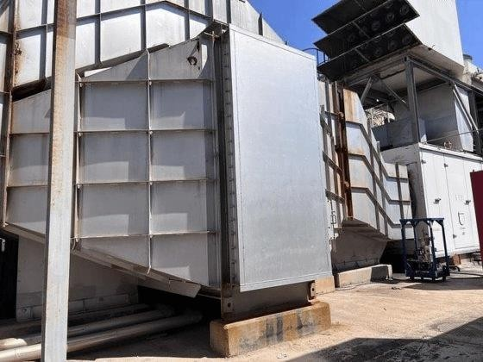
OWNER / SELLER TECHNICAL SALES PRESENTATION

Package interface, pipework and adjacent plant equipment
Heat-recovery / exhaust-side equipment

Turbine Package, Intake and Exhaust Arrangement

The offered asset includes the principal turbine package and its installed intake, exhaust and supporting systems. The photographs below form part of the Owner’s current visual presentation of the equipment as available at site.
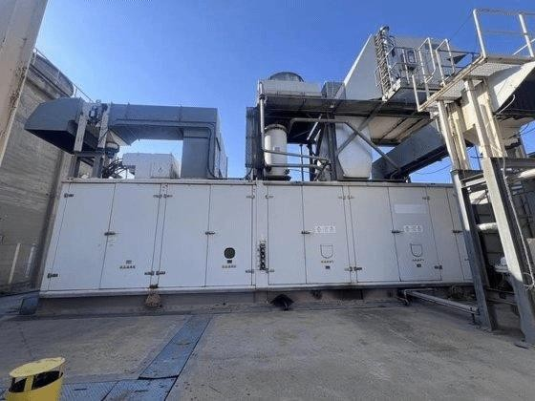
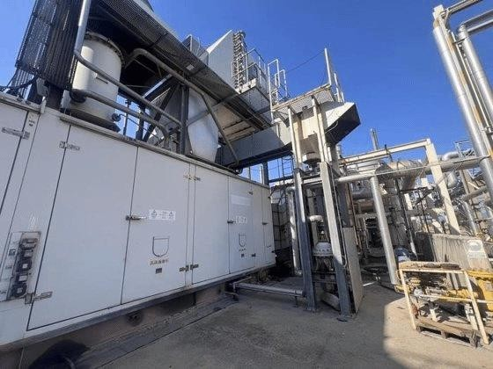
Gas turbine package - installed external view Package, ducting and access arrangement
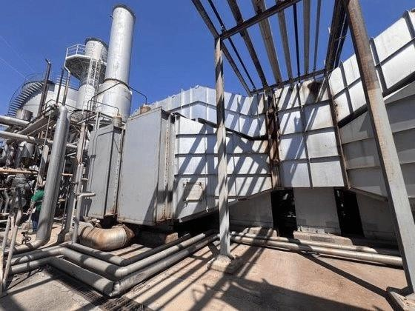
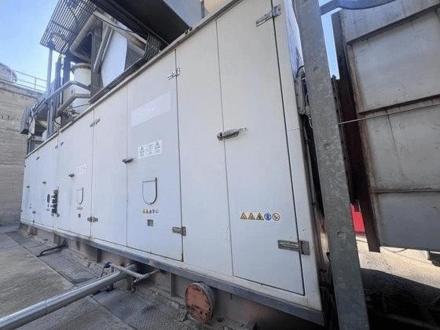
Exhaust / ducting and package interface Enclosure side and service-access view

Open service-access view of the turbine package

Reported turbine-island scope
  - Siemens SGT-300 gas turbine
  - Reduction gearbox
  - AC generator
  - Acoustic enclosure
  - Lubrication system
  - Gas fuel system
  - Air-intake filtration system
  - Exhaust system

Controls, Electrical and Auxiliary Systems

The sale scope includes the plant electrical and control equipment associated with the generating package, together with the reported automatic synchronization, fire-protection and auxiliary systems.
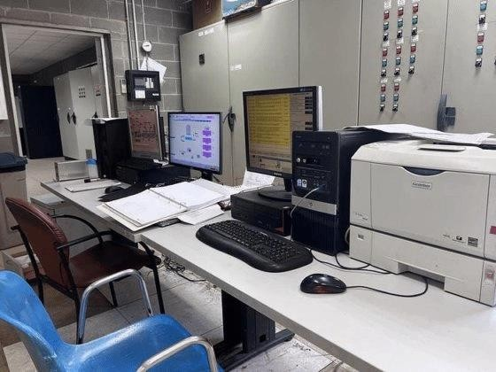
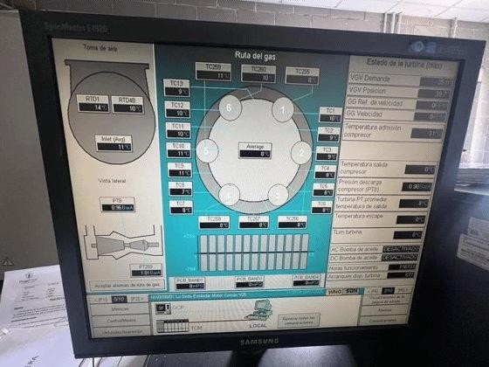
Control room / operator workstation Operator HMI display photographed at site
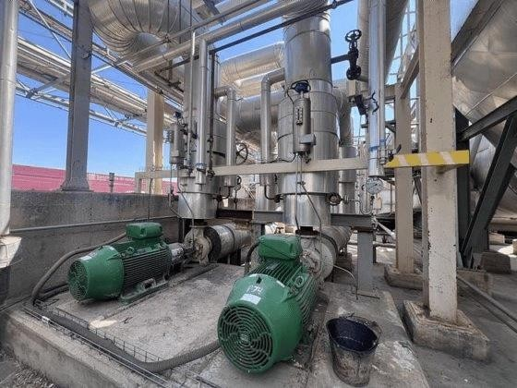
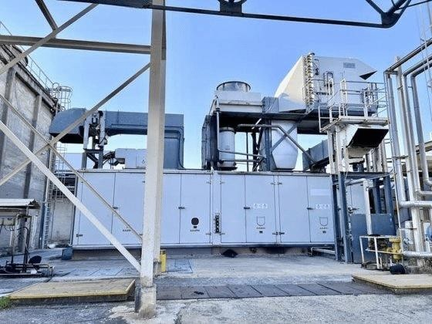
Installed auxiliary pumps / process auxiliaries Turbine package and associated equipment

Reported included systems
  - Electrical panels and generator control panel
  - Allen-Bradley ControlLogix control system
  - Automatic synchronization system
  - Fire detection and CO2 suppression system
  - Lubrication and fuel-gas auxiliaries
  - Associated plant auxiliary systems

Complete Reported Scope of Asset

Subject to confirmation in the final agreed equipment list and sale contract, the Owner’s present description of the available asset includes:
- Siemens SGT-300 gas turbine • Reduction gearbox
- 6.3 kV / 50 Hz AC generator • Acoustic enclosure
- Lubrication system • Natural-gas fuel system
- Air-intake filtration system • Exhaust system
- Heat-recovery train / HRSG • High-pressure steam generator
- Low-pressure steam generator • DOWNTHERM A thermal-oil heater - 4.3 MW
- SANTOTHERM 66 thermal-oil heater - 3.88 MW • Hot-water generator
- Single-effect absorption chiller - 1.7 MW cooling • Electrical panels
- Generator control panel • Allen-Bradley ControlLogix control system
- Automatic synchronization system • Fire detection and CO2 suppression system
- Associated auxiliary systems

The photographs in this presentation are intended to show the current installed asset and its principal visible equipment. They do not replace the final detailed equipment inventory, battery-limit definition or mutually agreed sale scope.

Operating History and Recent Major Work

Total running hours | 116,131 hours
Total starts | 677
HP rotor replacement | June 2025
Plant shutdown | November 2025 - cessation of host-site production

The HP rotor replacement in June 2025 is a material recent maintenance event in the history of the machine. The Owner’s available information indicates an estimated approximately 8,000 hours of remaining operating time. Supporting maintenance documentation is available for review within the transaction process, subject to availability and disclosure arrangements.

Available documentation
  - Technical specifications
  - Operating and maintenance manuals
  - Electrical documentation
  - Process documentation
  - Engineering drawings
  - Maintenance documentation
Serious prospective purchasers will be afforded an opportunity, by prior arrangement, to review the available technical records and inspect the plant at its present location.


- Basis of Sale - AS IS, WHERE IS

The complete plant is offered for sale by the current Owner on an AS IS, WHERE IS basis, in its present installed condition and at its present location. The purpose of this technical sales presentation is to provide serious prospective purchasers with an initial description of the asset and the information presently available to the Seller.
Unless expressly agreed otherwise in the definitive sale contract, the purchaser will be responsible for satisfying itself as to the condition, completeness and suitability of the plant for its intended application and destination, and for the engineering and execution of dismantling, preservation, packing, transport, reinstallation, integration and recommissioning.
All technical figures in this presentation are based on the information presently available to the Owner. Final scope, condition, documentation to be transferred, commercial terms, responsibilities and handover arrangements will be those expressly agreed between Seller and Buyer in the definitive contract of sale.

Invitation to serious prospective buyers
The Owner invites expressions of serious interest from industrial operators, energy users, project developers and qualified equipment purchasers with a genuine requirement for a gas-turbine CHP / regeneration asset of this capacity and configuration.
Following an initial review of this presentation, qualified interested parties may request access to further available technical information and arrange a site inspection. Commercial discussions will proceed directly with serious prospective purchasers following confirmation of interest and transaction capability.
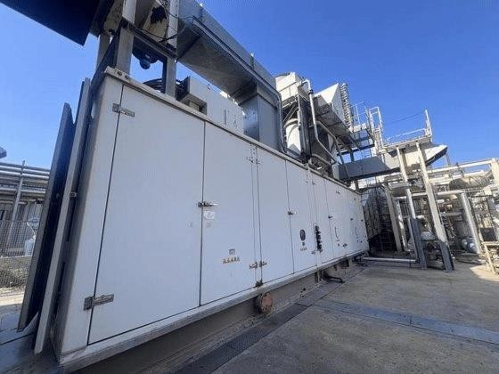
Current installed gas turbine package - offered as part of the complete CHP / regeneration asset AVAILABLE FOR SALE | SERIOUS ENQUIRIES ONLY
More photos

